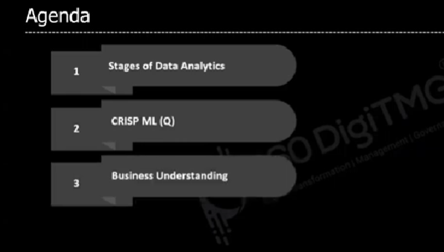

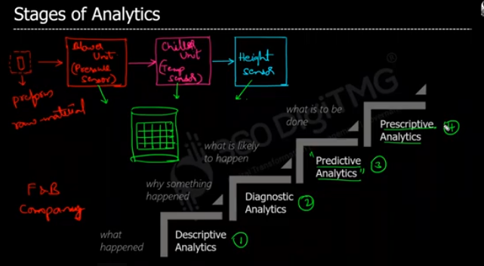

In prescriptive analysis(what should happen) we will play with predicted analysis data with the condition called “what if”, actually we will explore all the available options of predictive analysis to use the right one. From that we will know what is good, what is bad.

EX:

1. What will happen if covid 19 peoples are increased more than lakhs?
2. Should I give free vaccine?

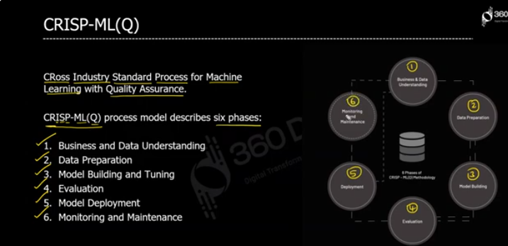

Crisp-ML is project management methodology any of your data related project. We can have multiple objectives

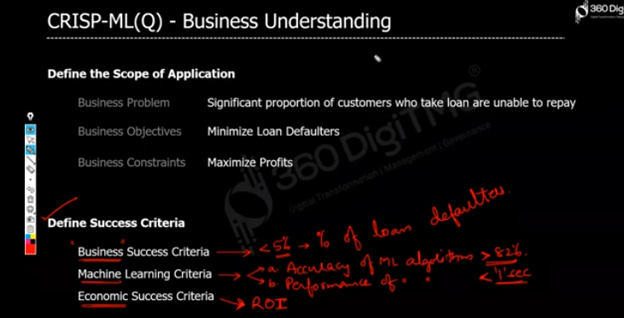

EX: Assume we developed a bank loan approver analysis system to analysis is the loner will be pay the loan in given 28 month, our model will analysis this with the loner’s age, education qualification, job status, If any one of these not satisfied well our model will rejects the loner, but if it rejects the loaner we will not have profit, so we also have to do survival analysis, and that can be done by reducing the pay loan amount days 28 to 24.

Assum model says this loaner will pay loan amount for 28 months after that there is 90% of chance the loner will not pay the loan, so we will reduce the time 28 to 24 to make more quick profit without loss.